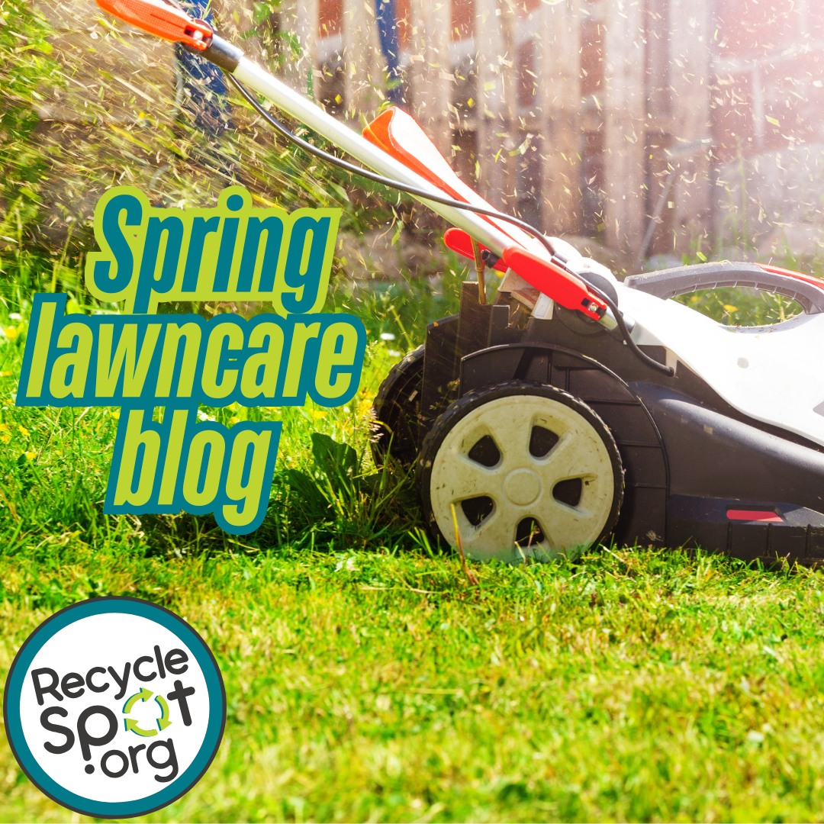 | Spring has sprung! As you green up your property, be sure to green up your habits to reduce waste going to landfills and prevent pollution in our region's air and water. For some great tips, read our latest blog.
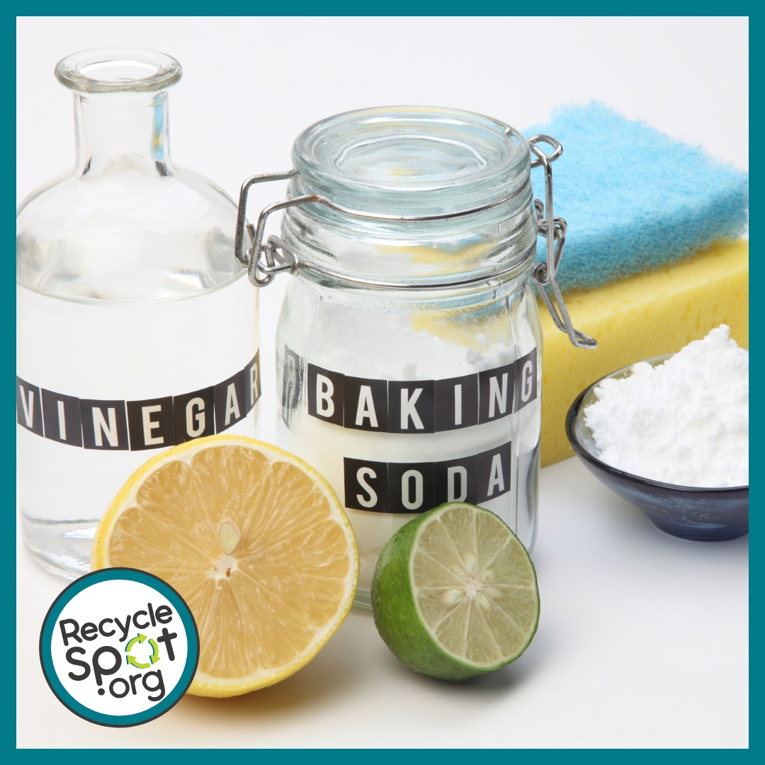 | Are you concerned about the safety of the chemicals you use in your house and yard? Make your own non-toxic solutions with time-tested recipes using common items from around your kitchen. Our new Safe Alternatives for Household Chemicals guide has over a dozen recipes using five or less items that will tackle everything from unwanted weeds to clogged drains, to pesky pests.
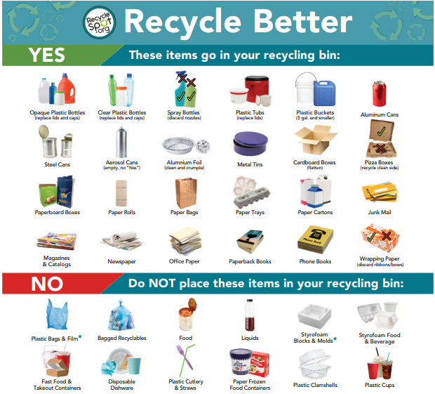 | Recycle more and better! RecycleSpot offers multiple resources to help you do just that. Print out a copy of the Recycle Better and Recycle Plastics Better flyers to make sure you’re recycling the right items in the right place. Both flyers are available in Spanish. And don’t forget to check out the Recycle Right section which has great tips for properly preparing your materials before recycling.
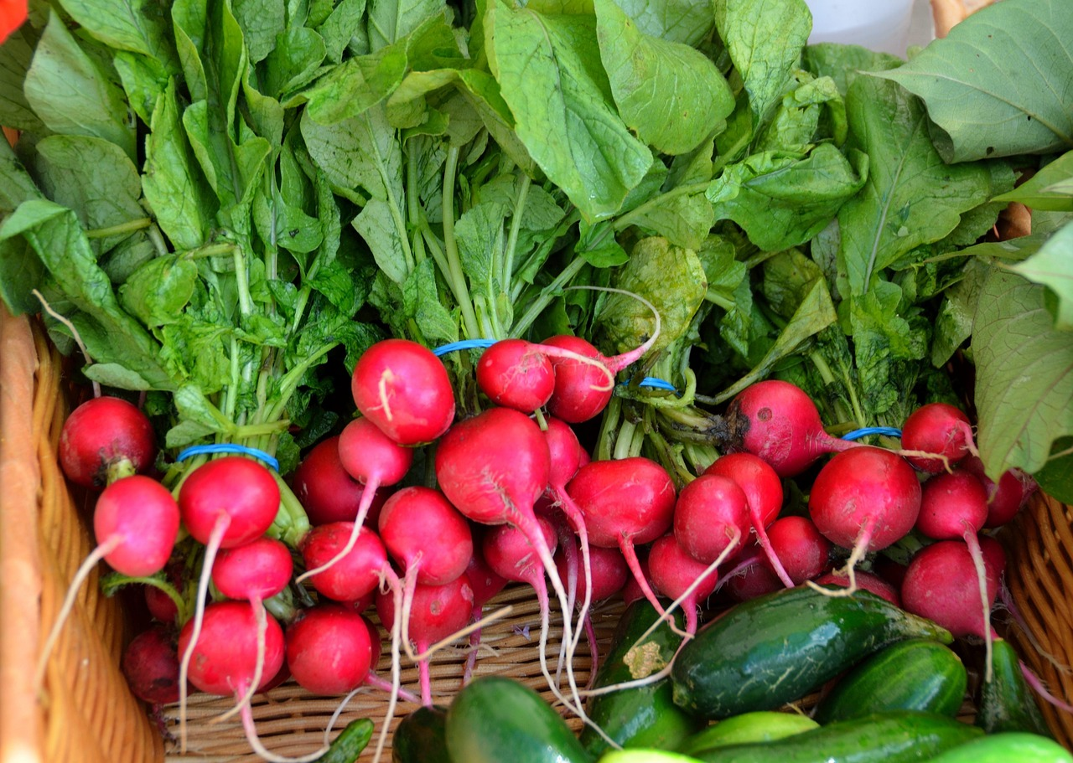 | KC-area farmers markets are now open! So come on out and buy organic foods produced locally. Don’t forget to bring your reusable shopping bags. For a complete list, visit the KCFoodWise Food System Map.

